**Socio-economic Impact of Special Economic Zones in the Provinces of the Dominican Republic**

**Hendrix Peralta 302311212**

**Introduction**

Special Economic Zones (SEZ) have been an important tool used by policymakers to promote development in targeted regions. However, previous literature has divided opinions regarding the economic and socio-economic impacts of SEZ in their host country. Nevertheless, the number of SEZ have been increasing steadily in the last 20 years (UNCTAD, 2019) and Dominican Republic is not the exception. Dominican Republic started their SEZ program in 1969 and since then has increased their parks count every year steadily. As a result, it possesses the largest quantity of SEZ of the Latin American region and their SEZ program has been widely considered as robust and successful in the region (World Bank, 2016).

Previous studies have tried to determine the socio-economic impacts of this zones with mixed results. In particular, Javaid et all (2023) denotes the contributions of SEZ to socio-economics factors such as financial stability, and infrastructural development for Indian districts. However, Mugano (2021) compares SEZ in China and Africa and explains that, if not managed properly the social cost of SEZ can overcome their benefits. This research attempts to add to the discussion by determining the effects of SEZ onsocio-economic factors in their respective provinces in Dominican Republic. In particular, we are going to attempt to answer the question “Does Special Economic Zones increase crime in the rovinces they are located?” by analyzing their impact in homicides as a proxy for crime.

**Data and method**

While previous studies have based their analysis on binary variables denoting the presence or absence of the sez in the regional units. This research attempts to look at the problem from a different perspective by additionally using internal data of the sez agglomerated to the provincial level as explanatory variables.

We will perform a two staged analysis where we first analyze try to answer our research question using only a dummy variable for SEZ and in a second step we will use internal data from the parks. Furthermore, we will use fixed-effects regression for both cases to account for missing variables and uniqueness across Dominican provinces. The models to use in each step are described below:

*Were crimepc* is the number of homicides per capita. SEZ is a dummy variable indicating if the province has SEZ parks or not. μ represents the time-fixed effects while representing the province-fixed effects. And εrepresents the error. i represents a province and at a time period.

For the second step, we will use equation 2. Our dependent variable crimepc is the number of homicides per capita. ent is the number of enterprises inside the SEZ parks. inv is the accumulated investment of the parks in $10,000,000 USD. Finally, tec_salary is the salary of the technicians working in the SEZ parks measured in $1000 RD. Additionally, μ represents the time-fixed effects while representing the province-fixed effects. Lastly,εrepresents the error while i represents a province and t a time period.

**Step 1**

In *Figure 1* we divide the provinces of Dominican Republic into two groups. We can observe that the provinces with SEZ, marked with 1, have a higher crime per capita than those that do not have them (marked with 0).

Figure 1. Crime per capita by SEZ presence status.

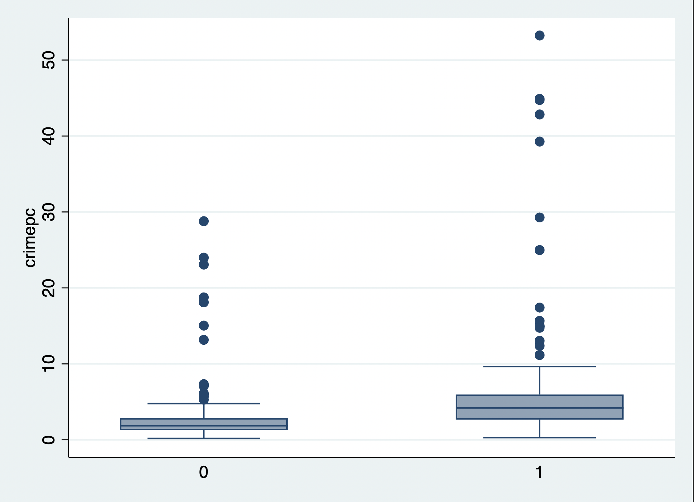

Source: author

After considering missing variables using 2-way fixed effects, the statistical significance of the variable sez is lost. However, we can observe on *Table 1* that the presence of the sez correlates positively with crime.

Table 1. Effect of SEZ presence on criminality

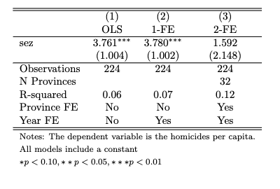

Table 1. Source: Author

**Step 2**

Consistent to the results of step 1, in *Figure 2* we can observe a positive correlation between the number of enterprises in SEZ parks and criminality.

Figure 2. Relationship of criminality and number of enterprises (ent)

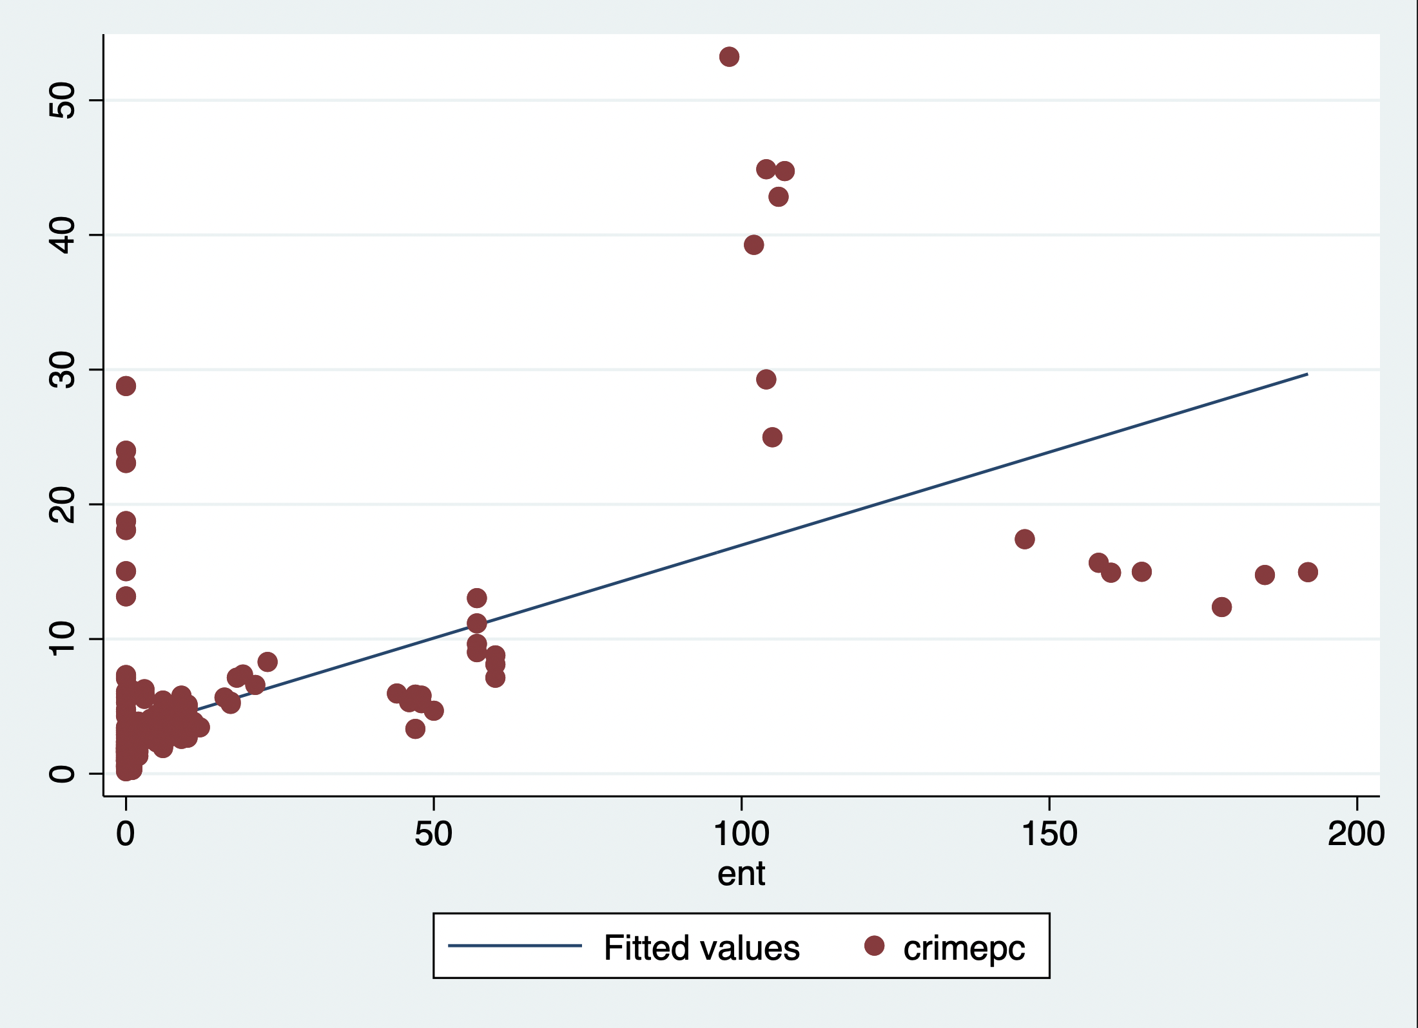

Figure 1. Source: author

In *Table 2*, we can see a more insightful analysis of our study. Were after applying 2-way fixed effects, the number of enterprises inside the sez correlates positively with crime and is statistically significant. This is consistent with the previous step results. However, park investment and technician salary coefficients are statistically significant and correlates negatively to crime. When analyzing the effects of SEZ in the Dominican Republic, provinces that receive higher investment and have better salaries for their employees could mitigate the adverse socio-economic effects of SEZ.

Table 2. SEZ enterprises, investment, and salary on criminality

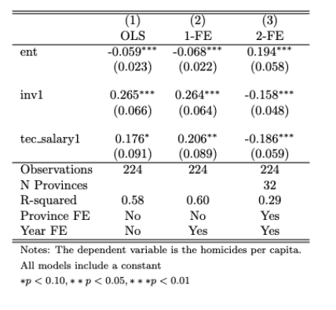

Source: Author

**Policy implications**

Utilizing the internal data of the parks can allow us to determine the impacts of each of their characteristics allowing us to acquire a better understanding of the results. Thus, contributing with more detailed policy recommendations.

Our result indicates that local government should aim for policies that incentivize investment when considering SEZ, such as tax exemptions according to investment. Furthermore, Policymakers should aim to increase infrastructure and human capital to attract higher skill jobs. This could result in a increase of the average payment of technicians and employees in general inside SEZ parks.

**Limitations**

This analysis faces several limitations due to the data structure and its availability. One of these limitations is that every year, new SEZ parks are opened throughout the nation. This characteristic limits our methodological options to determine the causal impact of the SEZ on the socioeconomic factors of the country. Furthermore, socio-economic data of municipalities (ADM2) or smaller administrations currently need to be made available for the Dominican Republic. However, future research should aim to determine the effects of SEZ in a smaller administrative region than in provinces. An analysis at a smaller administration level could lead to a more in-depth analysis and increase the observations from 32 per year to 170 per year. Finally, the location of SEZ is decided by government bodies and placed in provinces following specific criteria. Thus, their location is not random. Future research should utilize methods that can account for this to reduce bias in the results.

**References**

Javaid, L., Kousar, N., Anjum, F., Nida, N., Anwar, M., & Javaid, U. (2023). Sociological Study on Residents’ Perception of Special Economic Zone Regarding the Consequent Change in the Area; A Case Study of District Faisalabad. *Journal of South Asian Studies*, *11*(1), Article 1. <https://doi.org/10.33687/jsas.011.01.4704>

Mugano, G. (2021). The Impact of Special Economic Zones. In G. Mugano (Ed.), *Special Economic Zones: Economic Development in Africa* (pp. 115–140). Springer International Publishing. <https://doi.org/10.1007/978-3-030-82311-5_6>

UNCTAD. (2019). World Investment Report 2019—Special Economic Zones. *World Investment Report*.

World Bank (2016) Special Economic Zones In The Dominican Republic: Policy Considerations For A More Competitive And Inclusive Sector.

**Appendix**

**Data**

The data used in this paper were gathered from reports released by the National Council of Export Processing Zones (CNFE by its Spanish acronym) and transcribed manually by the author. The variables for investment (inv) and technicians’ salary (tec_salary) were scaled to 1/10000000 and 1/1000 scales, respectively.

**Robustness checks**

The models presented in this work did not pass the hettest indicating heteroscedasticity is present in the models. We tried to conduct a first difference analysis to solve it, but the coefficients were not significant, and their direction changed.

**Replicability**

The data and code used for the analysis can be found in the following GitHub repository:

[HendrixPeralta/sez_school-drops (github.com)](https://github.com/HendrixPeralta/sez_school-drops) Code file: Clean code.do